Extension pictures for web page

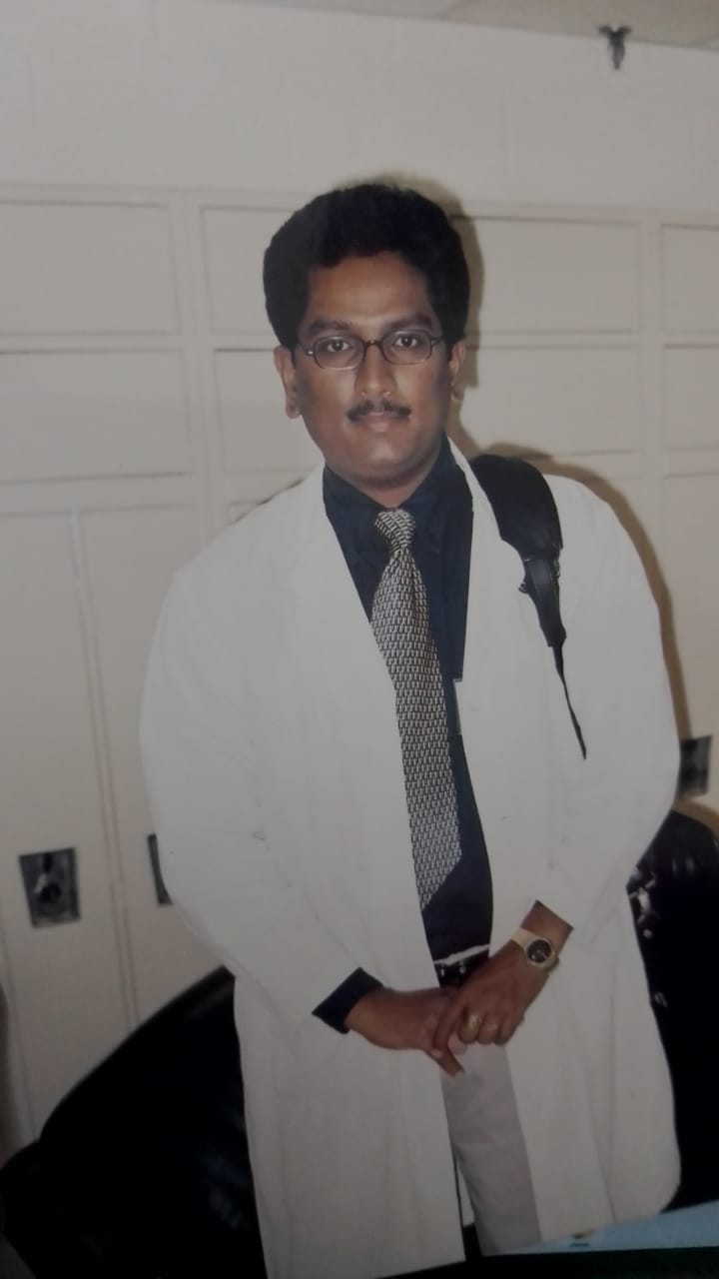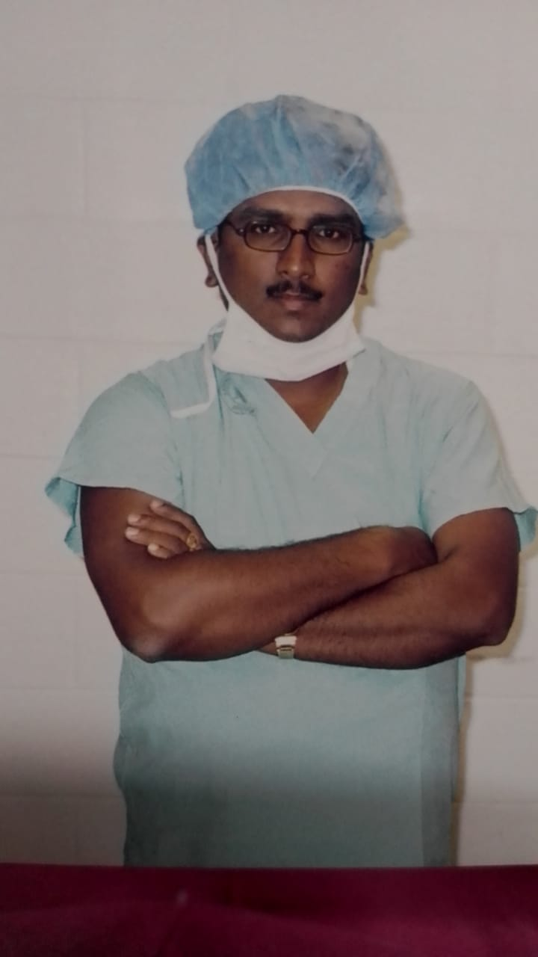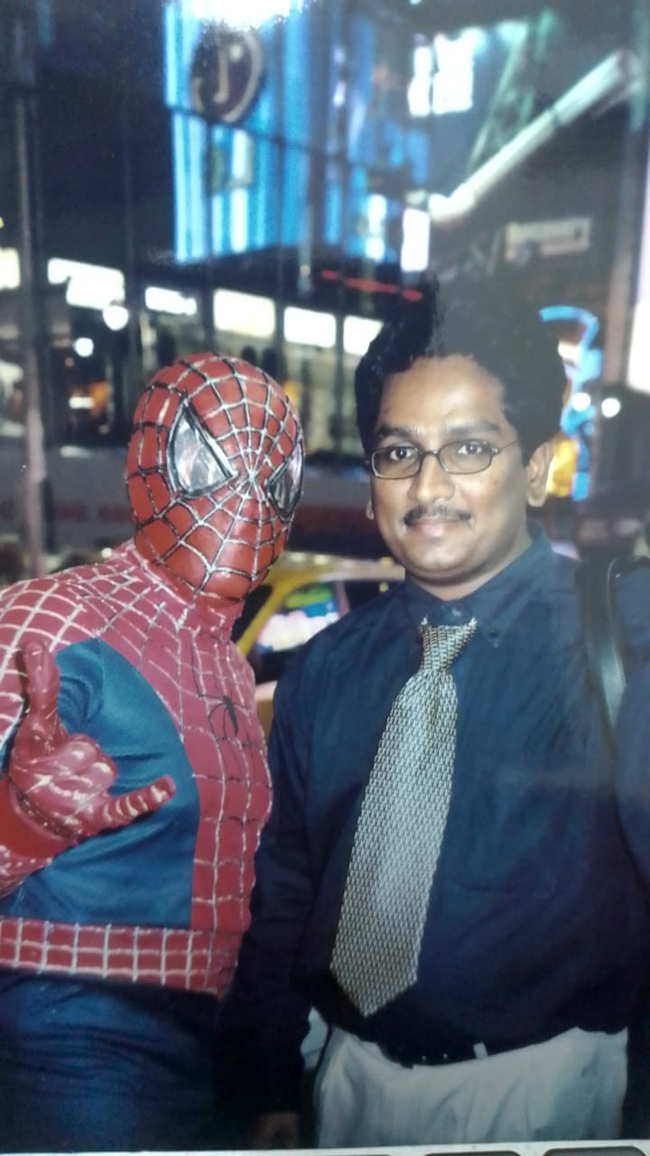

Dr. Suresh at New York

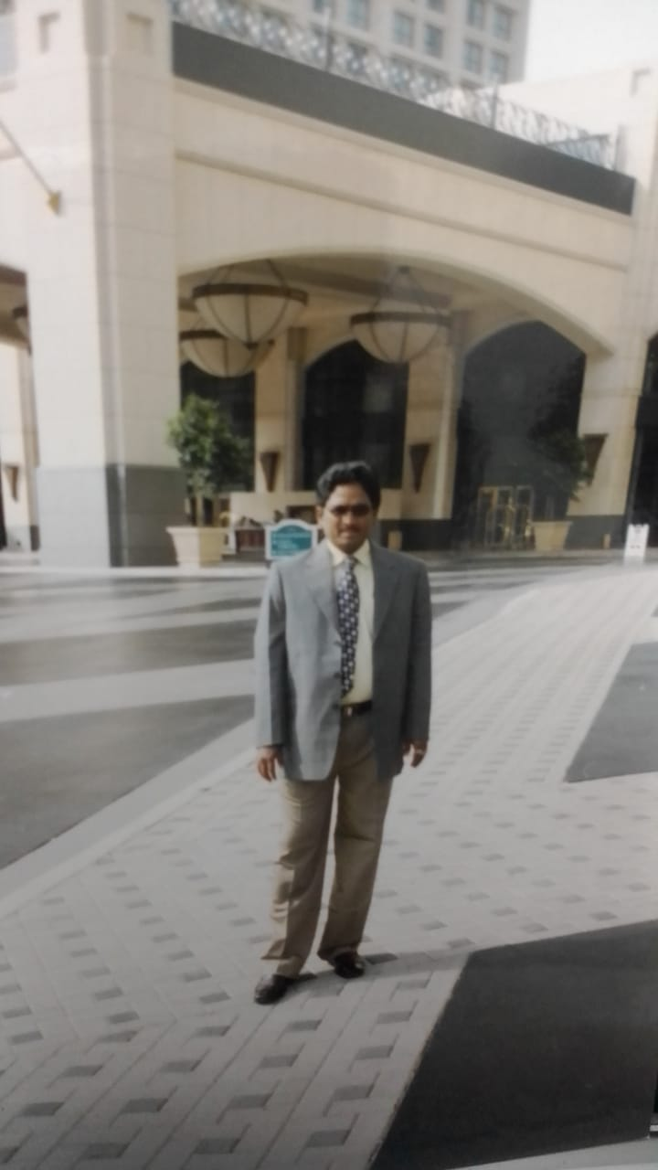

Dr. Suresh at Military hospital Riyad Saudi Arabia

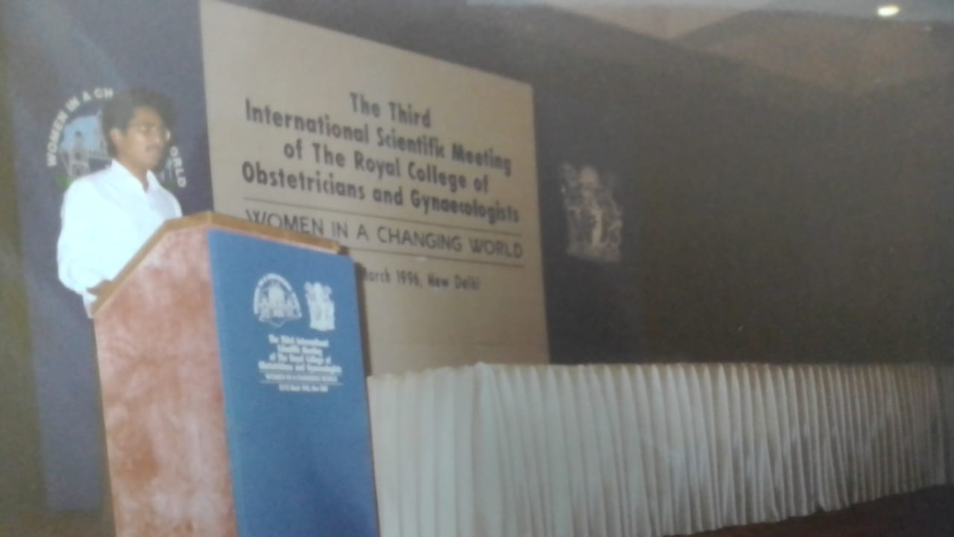

At New Delhi in RCOG Conference

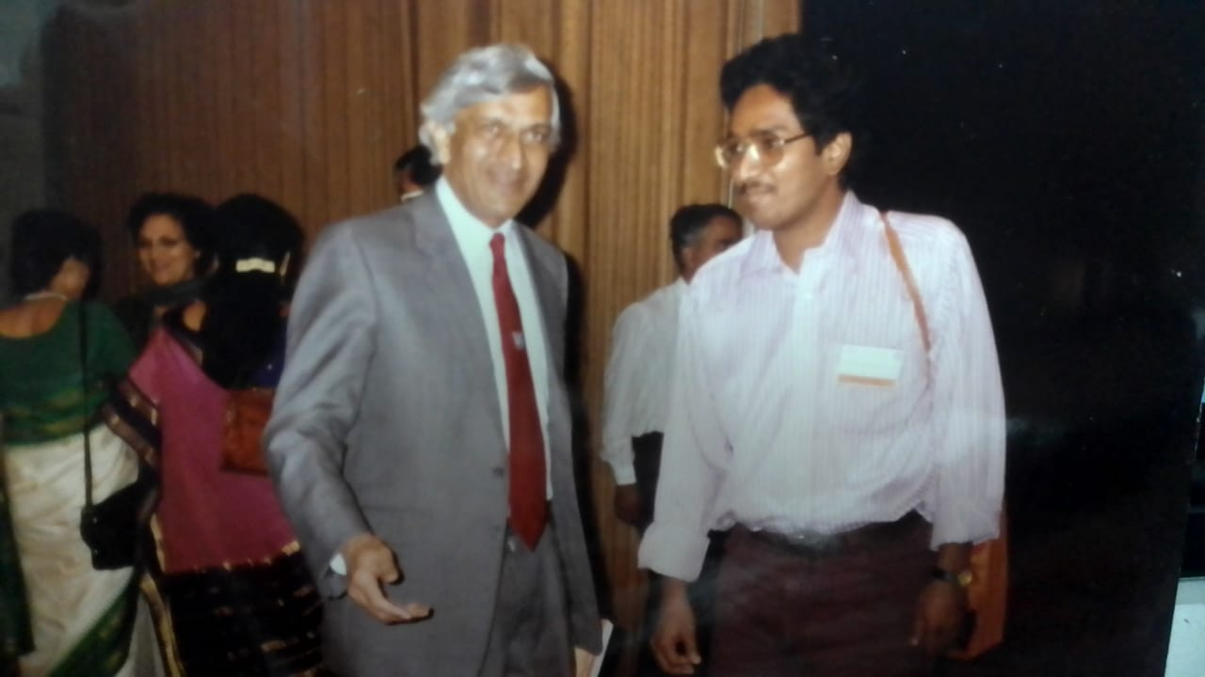

Dr. Patel RCOG President

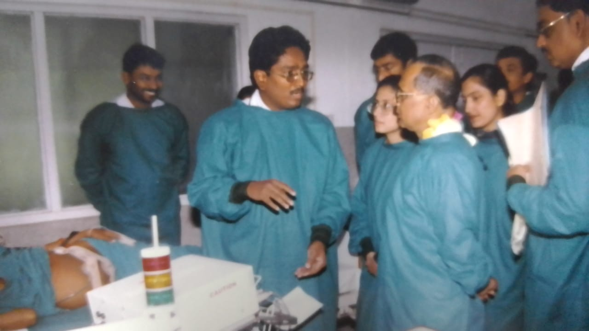

At MICU Dharan BPKIHS Dharan

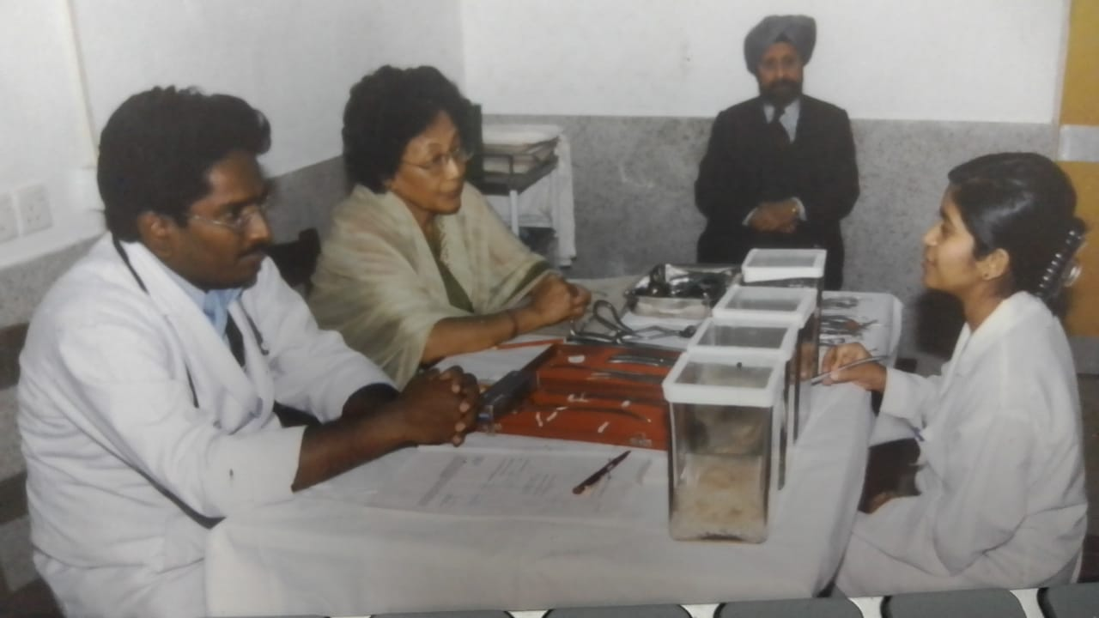

VIVA examination at BPKIHS Dharan

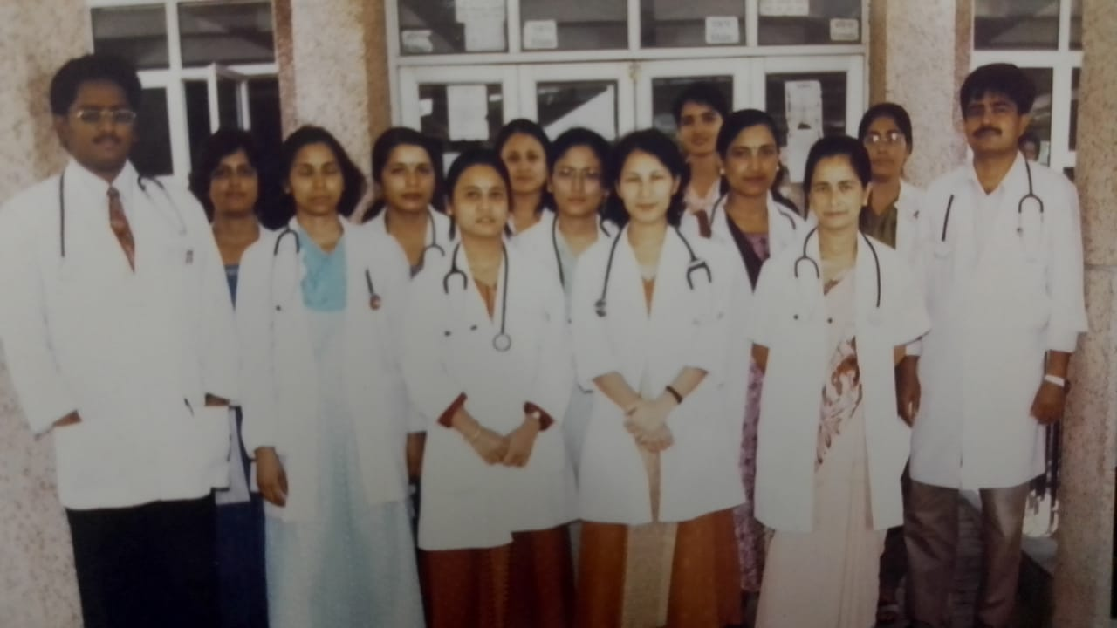

Dr. Suresh with OBGY Team at Dharan Nepal

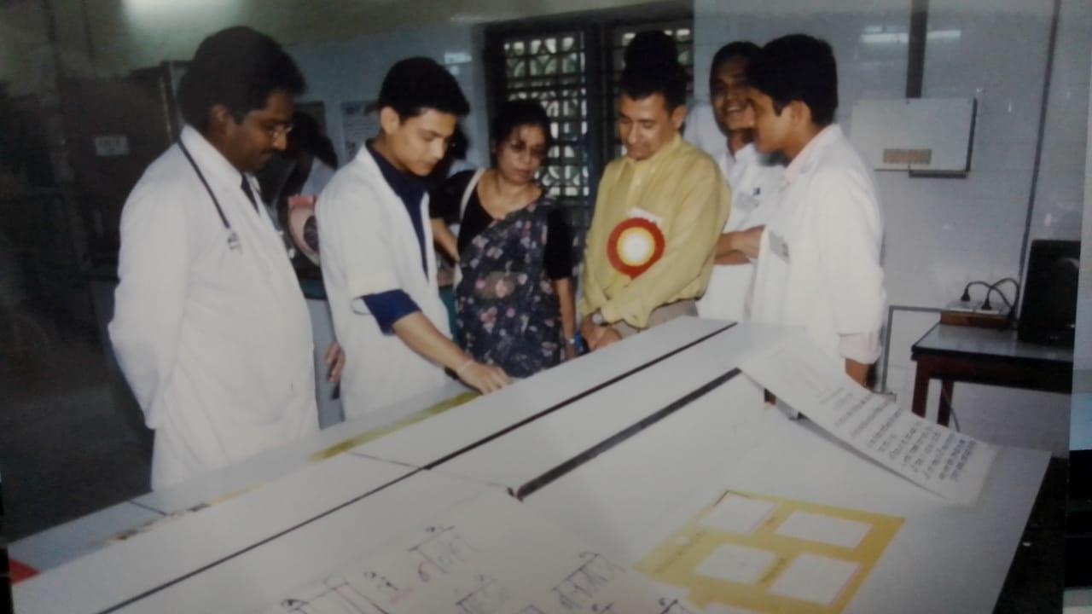

Dr. Suresh at Science exhibition Dharan

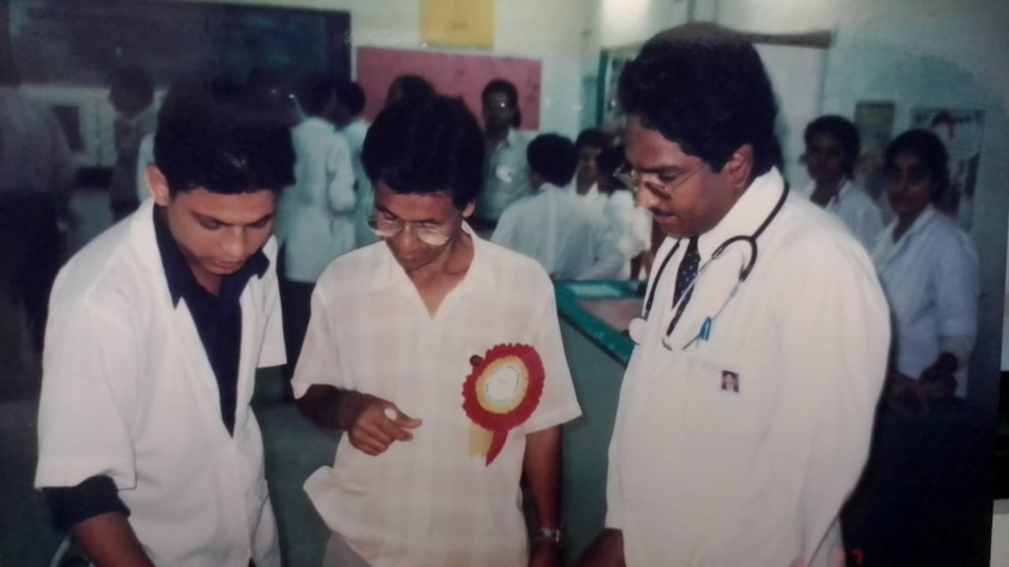

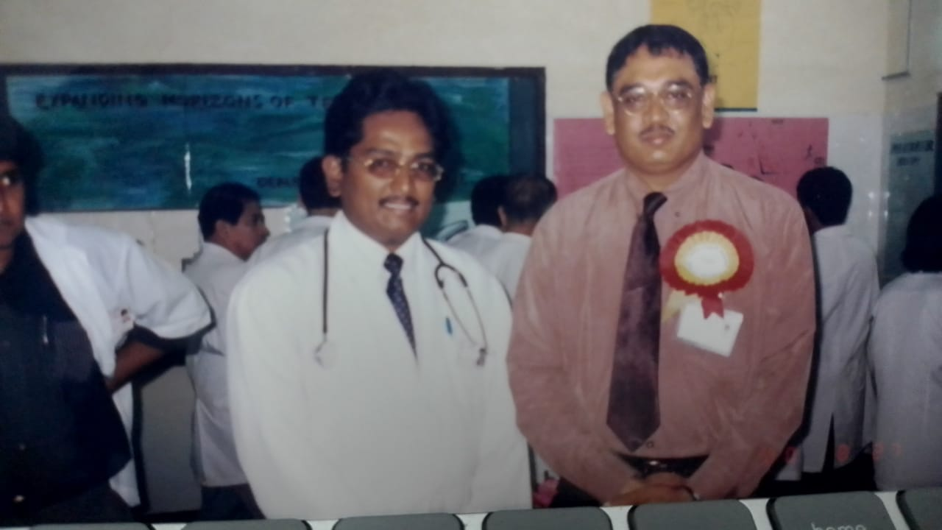

Dr. Suresh at B.P Koirala institute of Health sciences Hospital Director Nepal

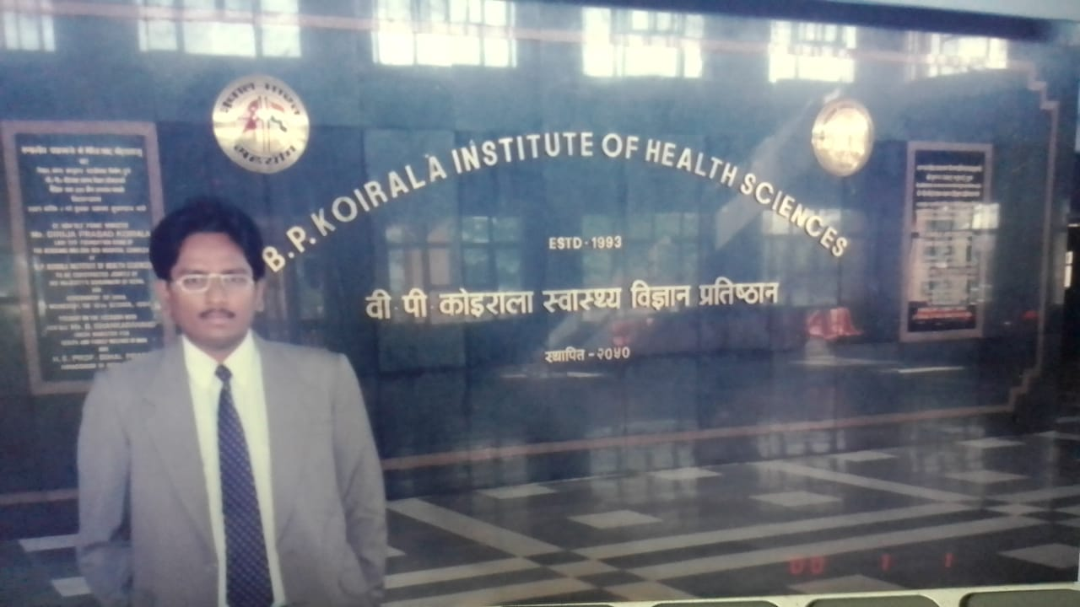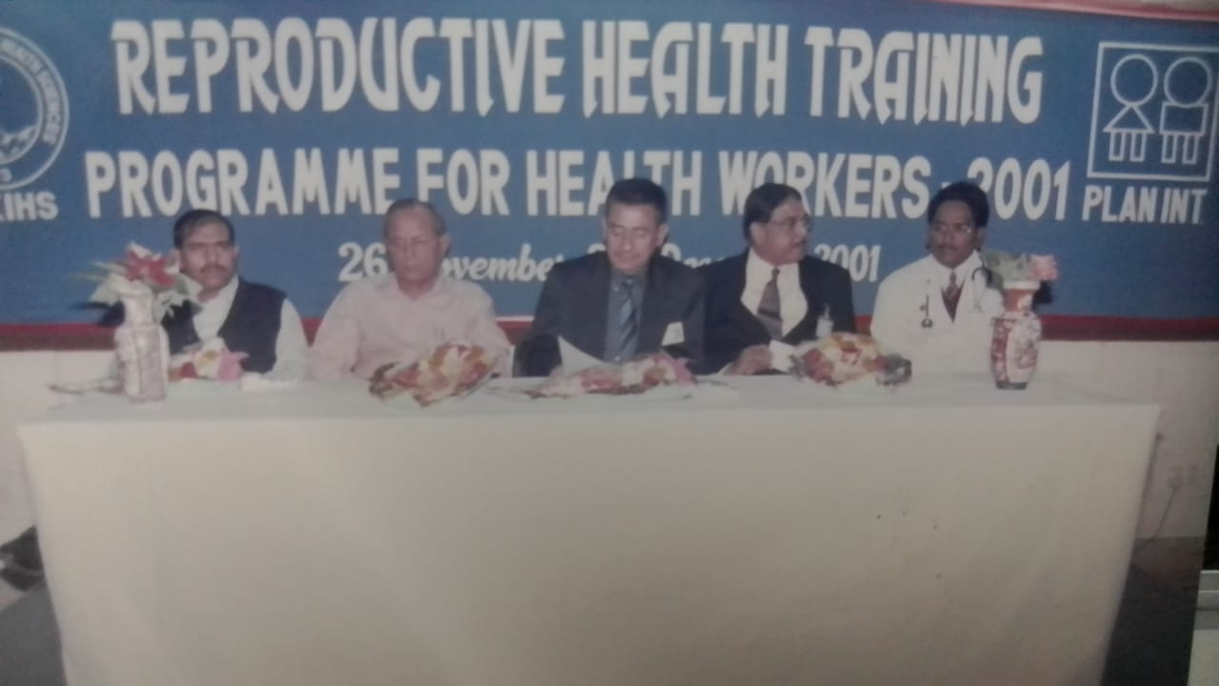

Dr. Suresh at RCH workshop Dharan Nepal

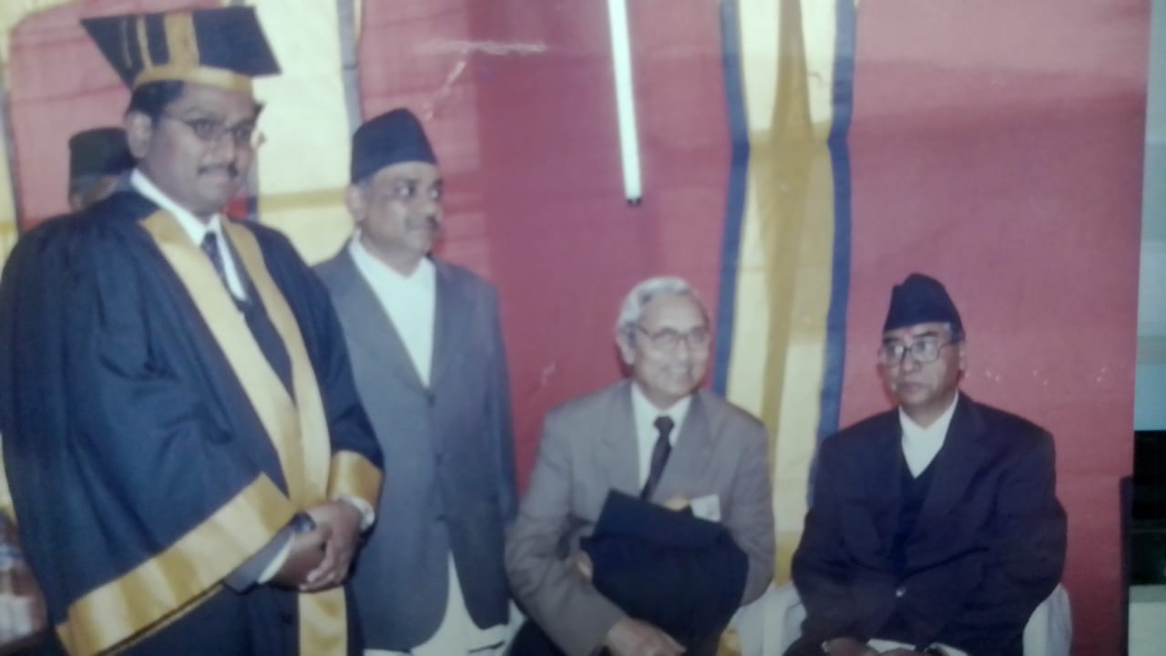

Dr. Suresh with Sher Bahadur Deuba who is Nepali politician and former prime minister of Nepal.

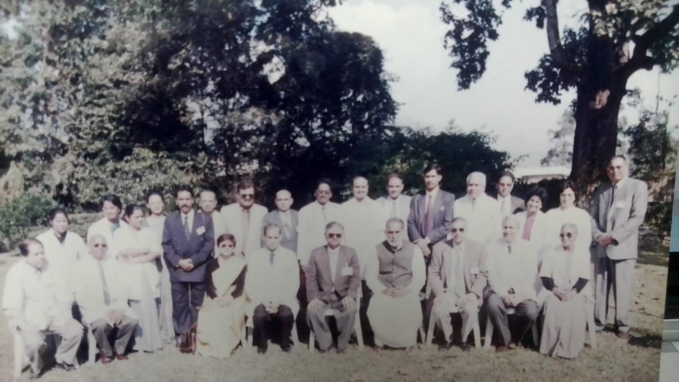

Dr. Suresh with former PM Chandrashekar and faculty members

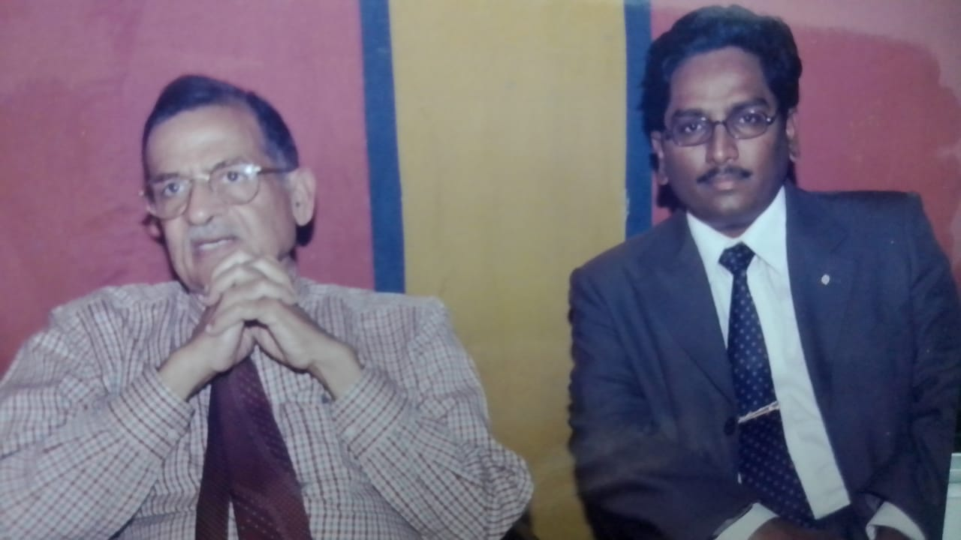

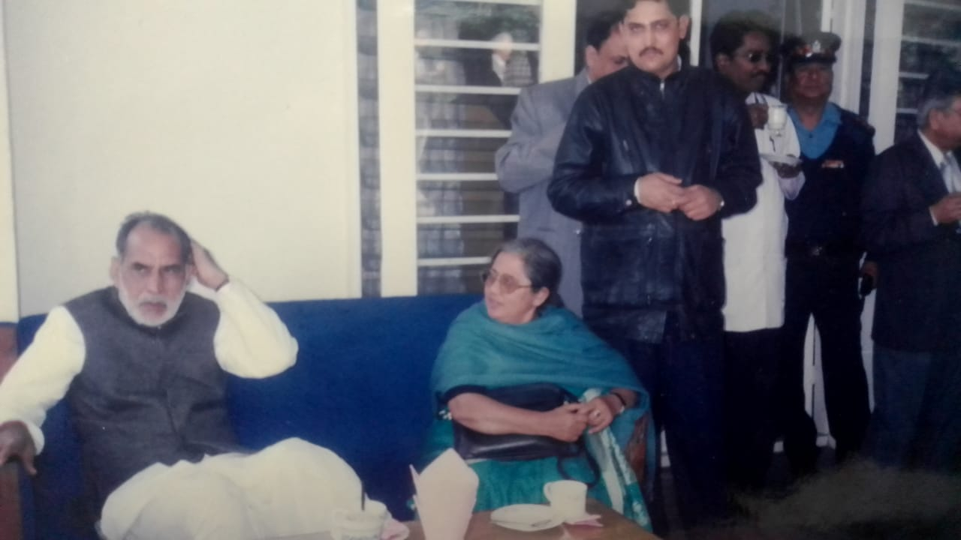

Dr. Suresh with former PM Chandrashekar and faculty members

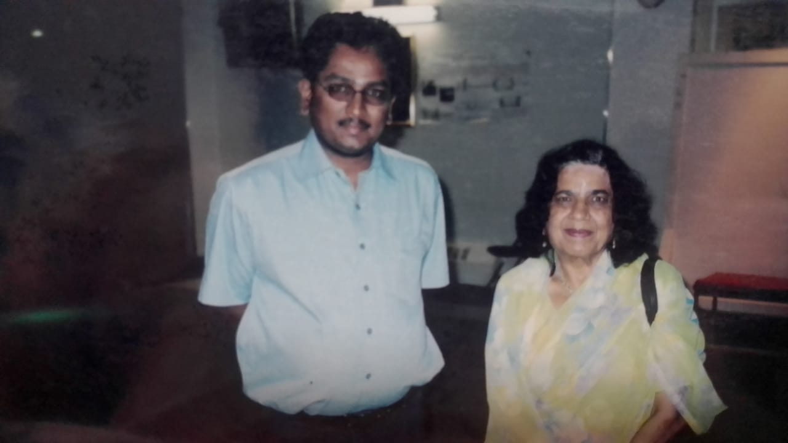

Dr. Suresh with **Dr. Goel** Gynaecologist, Healer, and Sri Sathya Sai Devotee

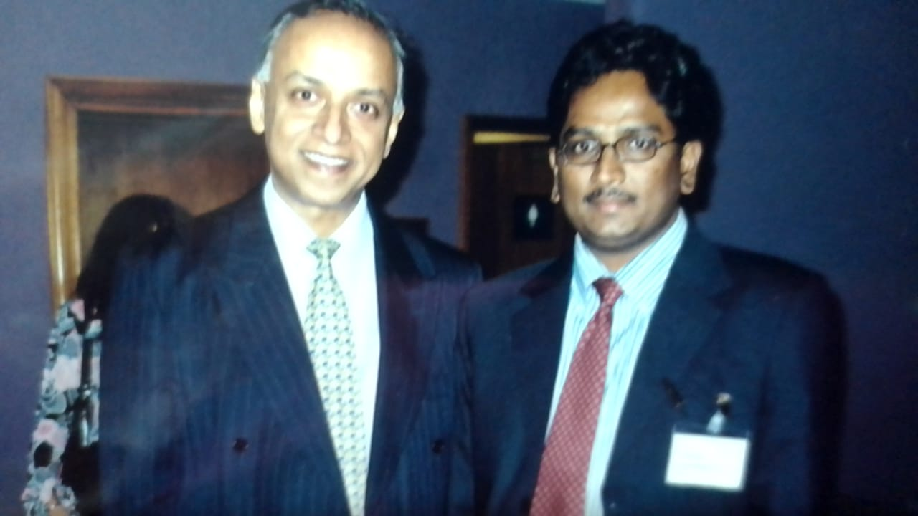

Dr. Suresh with Professor Arul Kumar ONGY UK

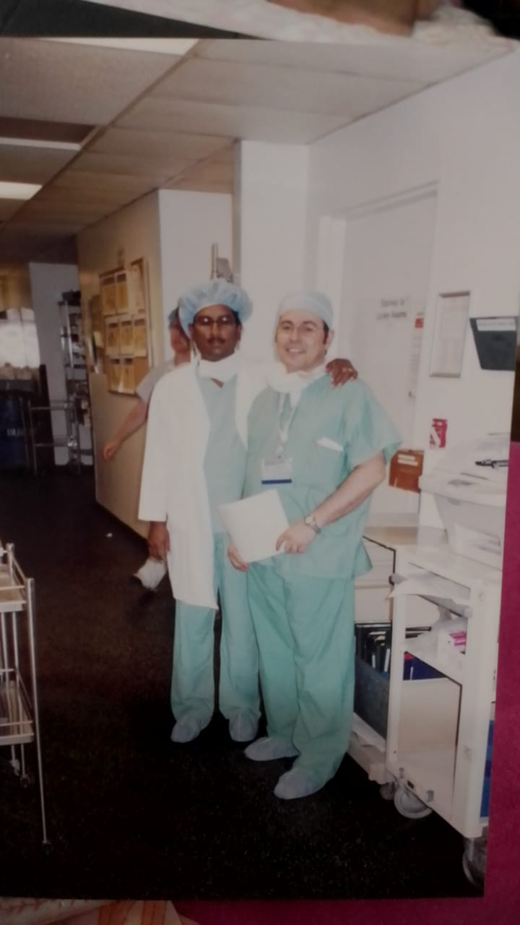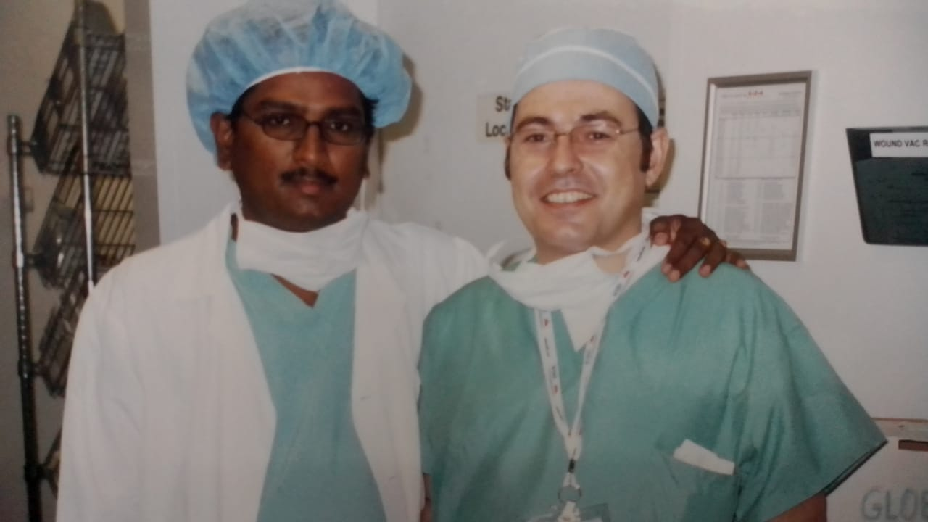

Dr. Suresh with his friend from Greece

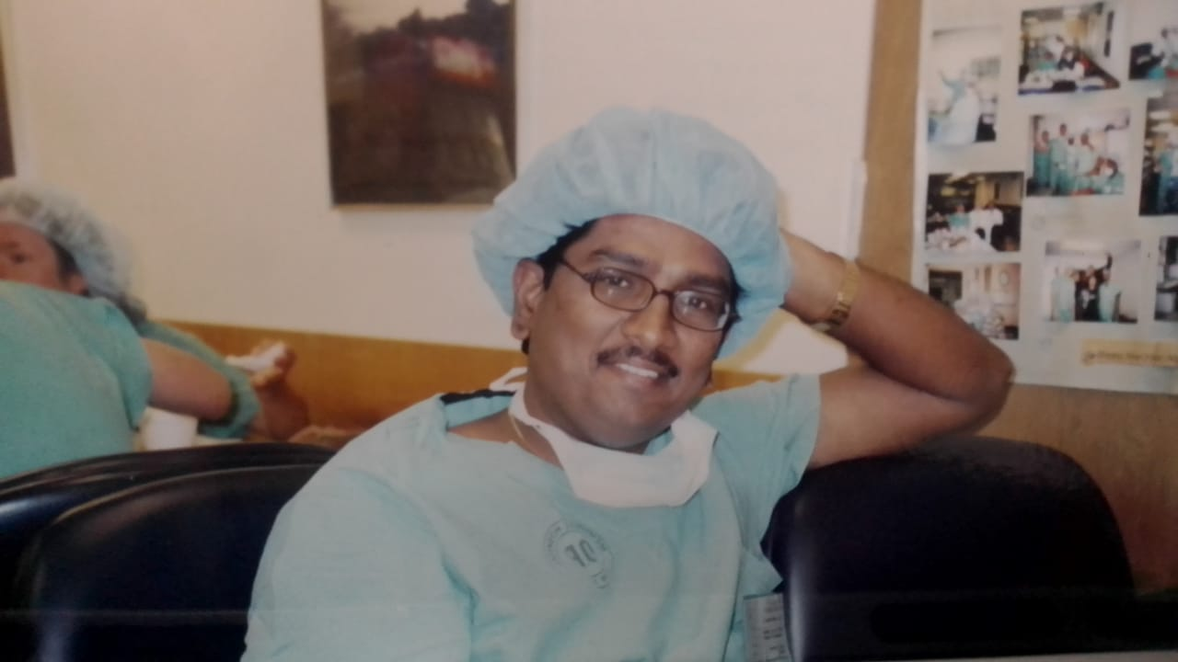

Dr. Suresh at MSKCC Hospital New York